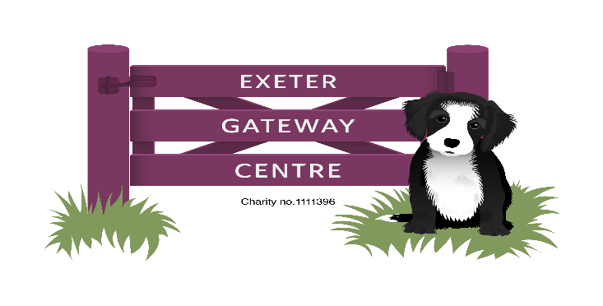
November and December 2025 Newsletter

Dear Members and Carers,

As we approach the festive period, we Iook back on what has been a busy and eventful year. The extension to the rear of the building was completed in January, and members have really enjoyed using it for both arts and crafts and as a quiet space. We are maintaining good numbers every day.

This year, members have visited Killerton House, IKEA, The South Devon Railway, Millfield School and the RAM in Exeter. At the centre, we’ve had weeks of pizzas, BBQs, pancakes and Chinese New Year meals. We celebrated Gateway’s 20th Anniversary in May, having an open day, which was attended by many members, families and support staff. Activities have continued with a broad range to choose from. Walking football is still popular, as are singing sessions on Tuesdays.

This year, on Monday 15th December, there will be a Christmas Party at St James’ Church Hall, from 12-3pm. It is open to all members and for those that don’t normally attend on Mondays, please arrive for midday and be collected by 3pm from the church. Please wear something festive! The plan is for members to bring a small, packed lunch to eat on arrival. There will be both sweet and savoury festive snacks available throughout the afternoon, plus games and dancing. Tuesday’s choir will entertain and then there will be a chance for everyone to join in with Christmas songs and carols.

As usual, we will be holding a Christmas Raffle-tickets will go on sale from the 1st December at £1 per strip. The draw will take place during the party and prizes chosen for any absentees on the day.

The centre has again been invited to decorate a Christmas tree at Killerton House. A group will being going over to the house at the end of November.

There won’t be a big trip out until next year-we will investigate attractions and the costs involved and discuss findings with the members, as we did with the trip on the railway.

It just leaves me to say thank you ^{from} all the staff for your continued support over this year and to wish you well for the festive season (when it arrives!).

Kind Regards
Daryl, Carolyn, Sharyn, Karen, Maria and Jonathan

NOTICES

If you won’t be attending on 22nd -24th December, please could you let us know so we can plan activities accordingly.

The centre doesn’t officially open until 10am, so could members arrive as near to then- it allows the staff time to prepare the kitchen and activities. Also, please notify the centre of any absence.

We have accumulated several items of ‘lost property’-coats, scarves and glasses! Please see a member of staff if you think you’ve lost something.

Gateway wrist bands still for sale-£1 each

…………………………………………………………………………………………

THE CENTRE WILL CLOSE AT 3PM ON THE 24th DECEMBER AND RE-OPEN AT 10AM ON MONDAY 5th JANUARY 2025.
MERRY CHRISTMAS AND A HAPPY NEW YEAR FROM ALL THE STAFF!

CHRISTMAS RAFFLE
TICKETS £1 PER STRIP
Tickets will go on sale on the 1st December-the draw will take place on the 15th December during the Christmas Party
………………………………………………………………………………………………………………………………..

Christmas Party

Name(s)……………………………………………….

I would like to attend the Christmas party on 15th December and enclose £3.

