we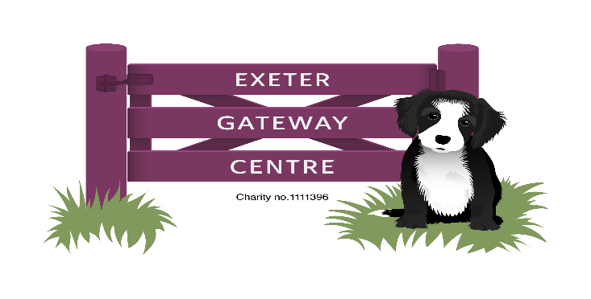
November and December 2024 Newsletter
Dear Members and Carers,

As we approach the festive period, I Iook back on what an eventful year we’ve had. Numbers have again increased-we now have 79 members on the books! Members have visited Killerton House, The Donkey Sanctuary, Millfield School and the National Marine Aquarium. In the centre, activities have continued with a broad range to choose from. Walking football is still popular, as are our new singing sessions on Tuesdays.

Our extension at the rear of the building should be finished soon, giving more space for arts and crafts but also allowing a quieter space too in the afternoons.

We finally achieved our goal by reaching Blackpool on our virtual bike ride. The total raised is £475, which will be split equally between the centre and FORCE cancer charity. Well done to everyone that took part-over fifty members, staff, volunteers and students cycled at least one kilometer!

Again, this year, there will be a Christmas Dinner in the form of a ‘Left-overs Lunch’-there will be cold meats, roast potatoes, salad, sausage rolls and other savouries followed by Christmas Pudding and mince pies. We are unable to use AGE UK’s facilities, so we have hired St James’ Church Hall for the lunch. It will take place on the 19th December between 12.30-3pm. It is open to all members and for those that don’t normally attend on Thursdays, please arrive for 12.15pm and be collected by 3pm from the church. Please wear something festive!

As usual, we will be holding a Christmas Raffle-tickets will go on sale from the 2nd December at £1 per strip. The draw will take place during lunch and prizes chosen for any absentees on the day.

The centre has again been invited to decorate a Christmas tree at Killerton House. Hopefully, we will be able to take several members over to the house at the end of November.

It just leaves me to say thank you from all the staff for your continued support over this year and to wish you well for the festive season (when it arrives!).

Kind Regards
Daryl (and Carolyn, Debbie, Sharyn, Karen and Jonathan)

DATES FOR THE DIARY…

Saturday 8th Feb 2025, 10am-2pm, ‘Sharing Good Practice’.

A chance for trustees, staff and carers to meet up informally and discuss their experiences (more details to follow).

Saturday 10th May 2025 (TTBC)-Join us to celebrate Gateway’s 20th Anniversary!

NOTICES

The centre doesn’t officially open until 10am, so could members arrive as near to then- it allows the staff time to prepare the kitchen and activities. Also, please notify the centre of any absence.

We have accumulated several items of ‘lost property’-coats, scarves and glasses! Please see a member of staff if you think you’ve lost something.

I have had enquiries about extra polo-shirts-please let me know if you wish to purchase more (price to be confirmed).

Gateway wrist bands still for sale-£1 each

Name the Bear-we have a ‘large’ teddy bear looking for a good home! £1 a guess. Draw to be made at the Christmas Lunch.
……………………………………………………………………………………………

THE CENTRE WILL CLOSE AT 3PM ON THE 20th DECEMBER AND RE-OPEN AT 10AM ON THURSDAY 2nd JANUARY 2025.
MERRY CHRISTMAS AND A HAPPY NEW YEAR FROM ALL THE STAFF!

CHRISTMAS RAFFLE
TICKETS £1 PER STRIP
Tickets will go on sale on the 2nd December-the draw will take place on
………………………………………………………………………………………………………………………………..
Christmas Lunch


Name(s)……………………………………………….

I would like a Christmas Lunch on 19th December and enclose £8.

